Project 3 Custom Aspect: The Project3 Aspect examines if a call method manipulates/creates data or if the method call simply retrieves data.

Project3 Aspect

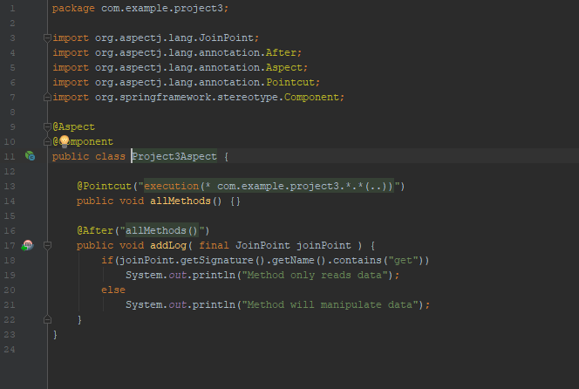

Project3 Aspect Annotation

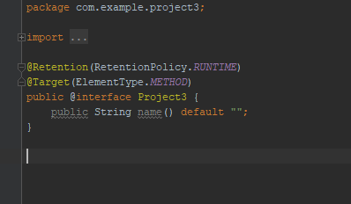

Controller with Project3 Aspect implementation

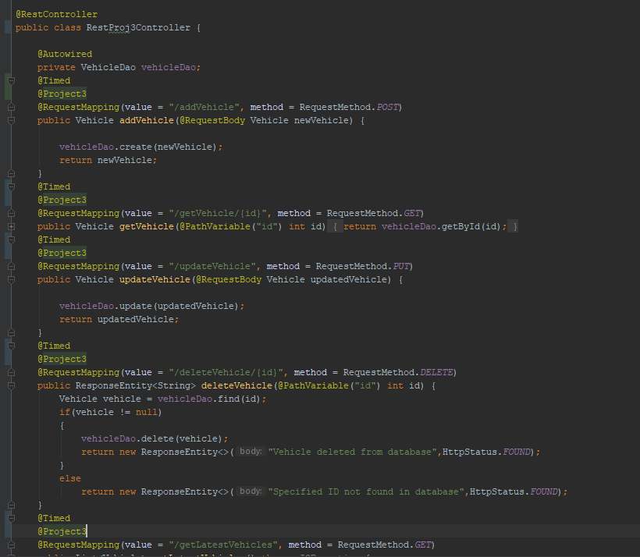

Console Output